

SIMATS ENGINEERING
SAVEETHA INSTITUTE OF MEDICAL AND TECHNICAL SCIENCES
CHENNAI-602105
Course Code & Name: ECA56 5G 6G Communication Systems
Name of student : S. Lalu prasad
Reg. No : 192312563
List of Experiments
- Simulation of FDMA in MATLAB
- Implementing TDMA Slot Allocation in GSM
- 5G NR Throughput for QPSK–256QAM
- OFDMA RESOURCS BLOCK Allocation
- MIMO System Simulation with BER Analysis
- Analog Beam forming
- Digital Beam forming
- Comparation of Analog, Digital and Hybrid Beam forming
- Steering Angle Variation in MIMO Beam forming
- Massive MIMO Capacity vs SNR and Gain
- Spectrum Analysis of Sub-1 GHz, Mid-band, mmWave by plotting propagation loss for 700 MHz, 3.5 GHz, 28 GHz
- 5G Throughput vs SNR with Modulation Labels
- NB-IoT vs LTE-M Throughput Simulation
- V2X Latency Comparison
- GFDM vs OFDMA Comparison using MATLAB
- mmWave Loss Components (28 GHz & 60 GHz)
- Implementing CDMA Encoding/Decoding using MATLAB or Python
- 5G NR Frame Structure Analysis with different Subcarrier Spacing
- 5G network slicing environment
- Implementation of IoT based Smart Agriculture using MATLAB

Ex1: Simulation of FDMA in MATLAB
AIM:
To simulate a Frequency Division Multiple Access (FDMA) system in MATLAB
PROCEDURE:
- Define the number of users, baseband signal parameters, and carrier frequencies for each user.
- Generate individual baseband signals (e.g., sine waves or random data) for each user.
- Modulate each user’s signal with a unique carrier frequency (frequency shifting).
- Combine all modulated signals to form the FDMA composite signal.
- At the receiver, apply band-pass filters to separate each user’s signal.
- Demodulate the filtered signals to recover the original baseband signals.
- Plot time-domain and frequency-domain signals to verify proper FDMA operation.
CODE
clear; close all; clc;

%% Parameters
Fs = 600e3; % Sampling frequency
t = 0:1/Fs:5e-3; % 5 ms duration
fm = 5e3; % Message frequency (≈ 5 kHz bandwidth)
fc = 20e3; % Carrier frequency 20 kHz

%% Message signal
m = sin(2*pi*fm*t);

%% Carrier signal
c = cos(2*pi*fc*t);

%% Modulated signal (DSB-SC)
s = m .* c;

%% ------------------------ PLOTTING -------------------------

figure;

subplot(4,1,1);
plot(t(1:1000), m(1:1000), 'LineWidth',1.3);
title('Message Signal (5 kHz)');
xlabel('Time (s)'); ylabel('Amplitude');
grid on;

subplot(4,1,2);
plot(t(1:1000), c(1:1000), 'LineWidth',1.3);
title('Carrier Signal (20 kHz)');
xlabel('Time (s)'); ylabel('Amplitude');
grid on;

subplot(4,1,3);
plot(t(1:1000), s(1:1000), 'LineWidth',1.3);
title('Modulated Signal (Message × Carrier)');
xlabel('Time (s)'); ylabel('Amplitude');
grid on;

%% ------------------------ SPECTRUM -------------------------

N = length(s);
S = abs(fft(s)/N);
f = (-N/2:N/2-1)*(Fs/N);

subplot(4,1,4);
plot(f, fftshift(S), 'LineWidth',1.3);
title('Spectrum of Modulated Signal');
xlabel('Frequency (Hz)');
ylabel('Magnitude');
grid on;
xlim([0 40e3]); % show 0–40 kHz

%% ----------- FIND PEAK FREQUENCY (Verification) -----------

[~, idx] = max(fftshift(S));
peak_freq = f(idx);

fprintf("\nSpectrum Peak Detected at = %.1f kHz\n", peak_freq/1000);
OUTPUT:
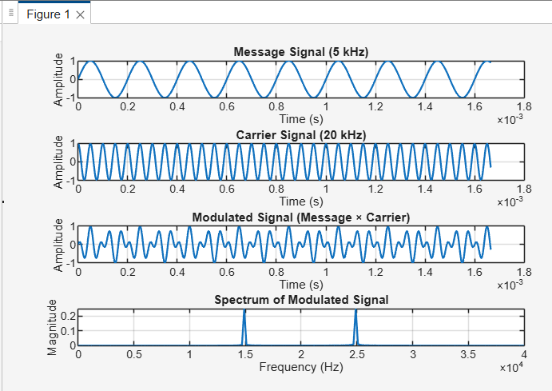
RESULT:
The FDMA system was successfully simulated in MATLAB.

Ex2: Implementing TDMA Slot Allocation in GSM
AIM:
To implement Time Division Multiple Access (TDMA) slot allocation as used in GSM
PROCEDURE:
- Define GSM TDMA frame parameters such as number of time slots per frame.
- Generate baseband data signals for multiple users.
- Assign each user a unique time slot within the TDMA frame.
- Arrange (multiplex) user data sequentially in time to form a TDMA frame.
- Transmit the combined TDMA signal over a common channel.
- At the receiver, extract data from the assigned time slots for each user.
- Display time-domain plots to verify correct slot allocation and separation.
CODE
clear; close all; clc;

%% Parameters
Fs = 1000; % Sampling frequency
T = 1; % Total duration of one frame (1 sec)
N = 3; % Number of users
t = 0:1/Fs:T-1/Fs; % Time vector

%% User Signals (Baseband)
user1 = sin(2*pi*5*t); % User 1: 5 Hz sine
user2 = sin(2*pi*10*t); % User 2: 10 Hz sine
user3 = sin(2*pi*15*t); % User 3: 15 Hz sine

%% TDMA Time Slots
slot_length = length(t)/N; % Samples per slot
tdma_signal = zeros(1,length(t));

% Assign time slots
tdma_signal(1:slot_length) = user1(1:slot_length);
tdma_signal(slot_length+1:2*slot_length) = user2(slot_length+1:2*slot_length);
tdma_signal(2*slot_length+1:end) = user3(2*slot_length+1:end);

%% ---------- PLOTS ----------
figure;

subplot(4,1,1);
plot(t, user1, 'LineWidth',1.2);
title('User 1 Signal (5 Hz)');
xlabel('Time (s)'); ylabel('Amplitude'); grid on;

subplot(4,1,2);
plot(t, user2, 'LineWidth',1.2);
title('User 2 Signal (10 Hz)');
xlabel('Time (s)'); ylabel('Amplitude'); grid on;

subplot(4,1,3);
plot(t, user3, 'LineWidth',1.2);
title('User 3 Signal (15 Hz)');
xlabel('Time (s)'); ylabel('Amplitude'); grid on;
subplot(4,1,4);
plot(t, tdma_signal, 'LineWidth',1.3);
title('Combined TDMA Signal');
xlabel('Time (s)'); ylabel('Amplitude'); grid on;
OUTPUT:
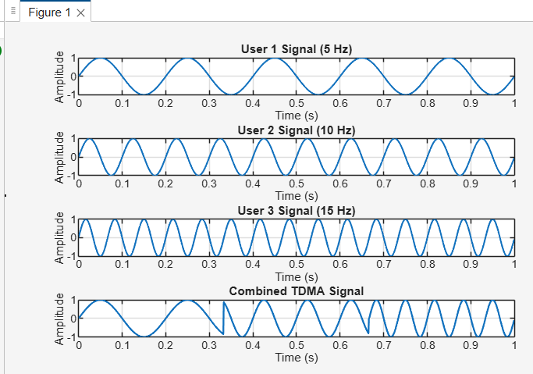
RESULT:
TDMA slot allocation was successfully implemented for a GSM system.

Ex3: 5G NR Throughput for QPSK–256QAM
AIM:
To analyze and compare the throughput performance of 5G NR for different modulation schemes ranging from QPSK to 256-QAM.
PROCEDURE:
- Define 5G NR system parameters such as bandwidth, subcarrier spacing, number of resource blocks, and coding rate.
- Select modulation schemes: QPSK, 16-QAM, 64-QAM, and 256-QAM.
- Generate random input data bits for transmission.
- Modulate the data using the selected modulation schemes.
- Calculate the achievable throughput for each modulation based on bits per symbol and resource allocation.
- Plot or tabulate throughput values versus modulation order.
- Compare the performance of different modulation schemes.
CODE
clear; clc; close all;
%% 5G NR Parameters
BW = 100e6; % Bandwidth (100 MHz)
subcarrierSpacing = 30e3; % 30 kHz SCS
Nsub = BW / subcarrierSpacing; % Total subcarriers
codeRate = 0.85; % Example coding rate
MIMO_layers = 4; % 4x4 MIMO

%% Modulation Schemes & Bits per Symbol
mod_scheme = {'QPSK','16QAM','64QAM','256QAM'};
bits_per_symbol = [2 4 6 8]; % bps for each modulation

%% Throughput Calculation
throughput = zeros(1,length(bits_per_symbol));

for i = 1:length(bits_per_symbol)

bps = bits_per_symbol(i);

% Throughput formula:
% T = (bits per symbol) * (no. of subcarriers) * (coding rate) * (MIMO layers)
T = bps * Nsub * codeRate * MIMO_layers;

throughput(i) = T / 1e6; % Convert to Mbps
end

%% Display Results
disp('5G NR Throughput for Different Modulation Schemes:');
for i=1:length(mod_scheme)
fprintf('%s Throughput = %.2f Mbps\n', mod_scheme{i}, throughput(i));
end

%% Plot Throughput
figure;
bar(throughput,0.6);
set(gca,'XTickLabel',mod_scheme,'FontSize',12,'FontWeight','bold');
xlabel('Modulation Scheme'); ylabel('Throughput (Mbps)');
title('5G NR Throughput for QPSK–256QAM');
grid on;
OUTPUT:
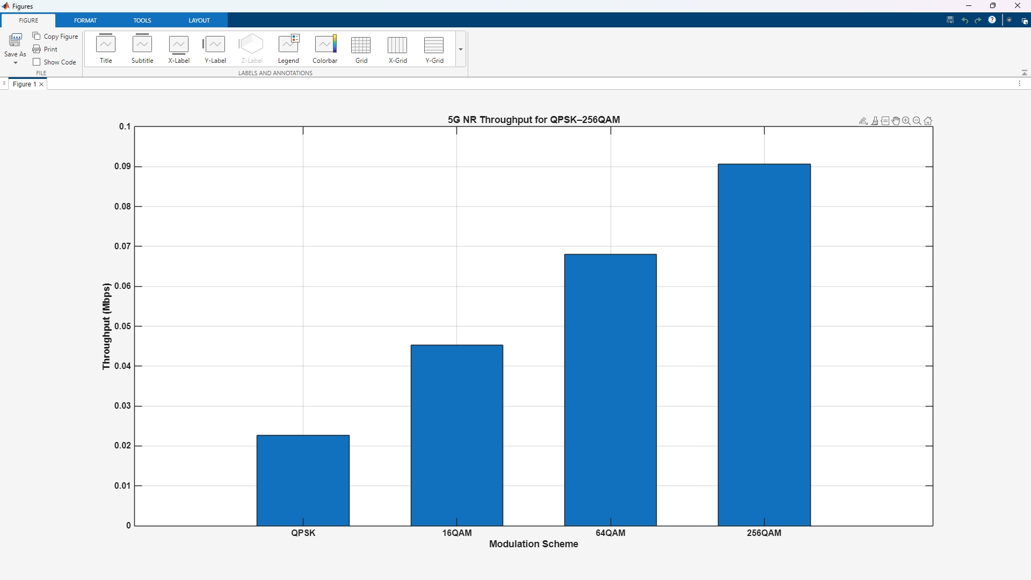
RESULT:
The throughput increased as the modulation order increased from QPSK to 256-QAM.

Ex4: OFDMA RESOURCS BLOCK Allocation
AIM:
To study and simulate OFDMA Resource Block (RB) allocation in a wireless communication system.
PROCEDURE:
- Define OFDMA system parameters such as bandwidth, subcarrier spacing, FFT size, and number of resource blocks.
- Generate data for multiple users in the system.
- Divide the available bandwidth into multiple subcarriers and group them into resource blocks.
- Allocate different resource blocks to different users based on a predefined allocation scheme.
- Map user data onto the allocated resource blocks.
- Perform OFDM modulation to generate the composite OFDMA signal.
- Display time–frequency resource allocation using plots.
CODE
clear; clc; close all;

%% PARAMETERS
N_RB = 20; % total resource blocks
N_users = 5; % number of users

%% ------------------ Equal Allocation ------------------
base = floor(N_RB / N_users);
rem = mod(N_RB, N_users);
alloc_equal = zeros(1,N_RB);
idx = 1;
for u=1:N_users
take = base + (u<=rem);
alloc_equal(idx:idx+take-1) = u;
idx = idx + take;
end

%% ------------------ Round-Robin Allocation ------------------
alloc_rr = zeros(1,N_RB);
for rb = 1:N_RB
alloc_rr(rb) = mod(rb-1, N_users) + 1;
end

%% ------------------ PLOT ------------------
figure;

subplot(2,1,1);
imagesc(alloc_equal);
colormap(parula(N_users));
colorbar('Ticks',1:N_users,'TickLabels',{'U1','U2','U3'});
title('Equal RB Allocation');
xlabel('Resource Block Index'); ylabel('Time Slot');

subplot(2,1,2);
imagesc(alloc_rr);
colormap(parula(N_users));
colorbar('Ticks',1:N_users,'TickLabels',{'U1','U2','U3'});
title('Round-Robin RB Allocation');
xlabel('Resource Block Index'); ylabel('Time Slot');

%% ------------------ DISPLAY ------------------
disp('Equal Allocation:');
disp(alloc_equal);

disp('Round-Robin Allocation:');
disp(alloc_rr);
OUTPUT:
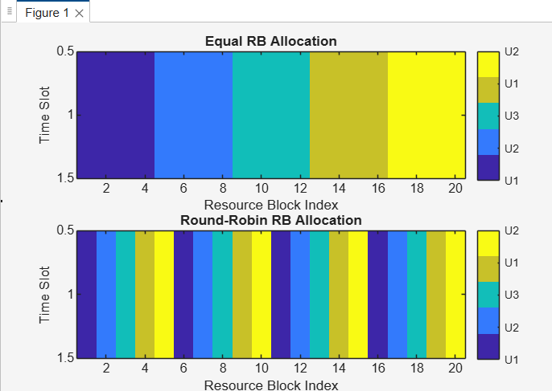
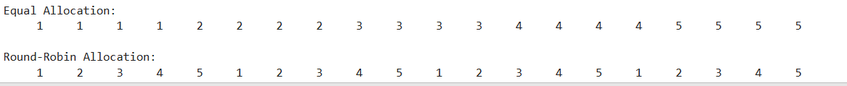
RESULT:
OFDMA resource block allocation was successfully implemented

Ex5: MIMO System Simulation with BER Analysis
AIM:
To simulate a MIMO (Multiple Input Multiple Output) communication system and analyze its Bit Error Rate (BER) performance.
PROCEDURE:
- Define MIMO system parameters such as number of transmit and receive antennas, modulation scheme, and SNR range.
- Generate random binary data for transmission.
- Modulate the data using a suitable digital modulation technique (e.g., QPSK or QAM).
- Transmit the modulated symbols through a MIMO channel (e.g., Rayleigh fading channel).
- Add noise corresponding to different SNR values.
- Apply MIMO detection/equalization techniques at the receiver (e.g., Zero-Forcing or MMSE).
- Demodulate the received symbols and compute BER.
- Plot BER versus SNR to evaluate system performance.
CODE:
clear; clc; close all;

%% PARAMETERS
numBits = 1e5; SNRdB = 0:2:20; bps = 2;

%% STUDENT INPUT: CHANGE MIMO ORDER
Nt = input('Transmit antennas Nt: ');
Nr = input('Receive antennas Nr: ');

%% QPSK SYMBOLS
bits = randi([0 1], numBits,1);
bits_reshape = reshape(bits, bps, []).';
symbols = (2*bits_reshape(:,1)-1) + 1j*(2*bits_reshape(:,2)-1);
symbols = symbols/sqrt(2);
numSym = length(symbols);

%% SIMULATION
BER = zeros(1,length(SNRdB));
for s = 1:length(SNRdB)
snr = 10^(SNRdB(s)/10);
noiseVar = 1/snr;

% Reshape symbols for MIMO
sym_tx = reshape(symbols, Nt, []).';

% Channel & noise
H = (randn(Nr,Nt,size(sym_tx,1))+1j*randn(Nr,Nt,size(sym_tx,1)))/sqrt(2);
n = sqrt(noiseVar/2)*(randn(Nr,size(H,3))+1j*randn(Nr,size(H,3)));

% Receive & Zero-Forcing
y = zeros(Nr,size(H,3));
x_hat = zeros(Nt,size(H,3));
for k=1:size(H,3)
y(:,k) = H(:,:,k)*sym_tx(k,:).' + n(:,k);
x_hat(:,k) = pinv(H(:,:,k))*y(:,k);
end
% Demodulate
x_hat_vec = x_hat.'; x_hat_vec = x_hat_vec(:);
bits_rx = zeros(numBits,1);
bits_rx(1:2:end) = real(x_hat_vec)>0; bits_rx(2:2:end) = imag(x_hat_vec)>0;
BER(s) = sum(bits~=bits_rx)/numBits;
end
%% PLOT
figure; semilogy(SNRdB, BER,'-o','LineWidth',2);
grid on; xlabel('SNR (dB)'); ylabel('BER');
title(sprintf('%dx%d MIMO BER vs SNR (QPSK, ZF)', Nt, Nr));
OUTPUT:
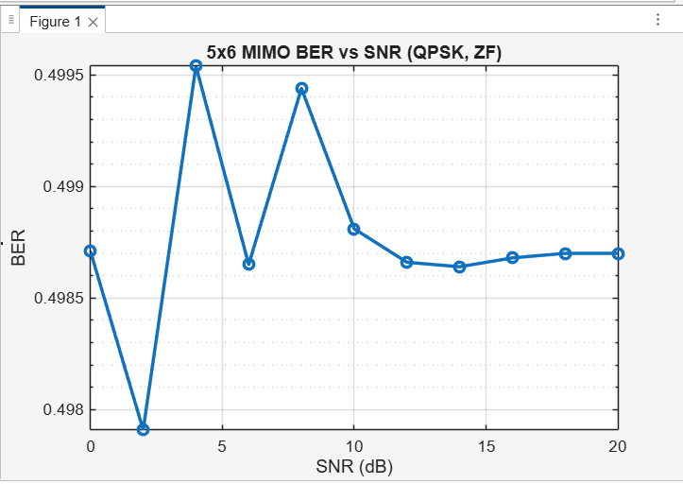
RESULT:
The MIMO system was successfully simulated, and BER performance was analyzed. The results showed that BER decreases as SNR increases, indicating improved reliability.
Ex6: Analog Beamforming
AIM:
To study and simulate Analog Beamforming and analyze how directional signal transmission improves signal strength.
PROCEDURE:
- Define antenna array parameters such as number of antenna elements, element spacing, and operating frequency.
- Generate a transmit signal for the user.
- Apply phase shifts to each antenna element using analog phase shifters to steer the beam in a desired direction.
- Combine the signals from all antenna elements to form a directional beam.
- Transmit the beamformed signal through the channel.
- Analyze the radiation pattern and beam direction using MATLAB plots.
- Observe the effect of beam steering on signal gain.
CODE:
clc; clear; close all;

%% Parameters
lambda = 1; % Wavelength
d = lambda/2; % Antenna spacing
theta = -90:0.1:90; % Angle scan range (degrees)
theta_rad = deg2rad(theta);

% Array sizes to analyze
N_array = [8 16 32 64];
beamwidth = zeros(1, length(N_array));

for idx = 1:length(N_array)
N = N_array(idx);

% Steering direction (broadside)
theta0 = 0;
theta0_rad = deg2rad(theta0);
% Array Factor Calculation
AF = zeros(size(theta_rad));
for n = 0:N-1
AF = AF + exp(1j * 2*pi*(d/lambda)*n*(sin(theta_rad) - sin(theta0_rad)));
end
% Normalize
AF_norm = abs(AF) / max(abs(AF));
% ---- Compute 3-dB Beamwidth ----
mainlobe_max = max(AF_norm);
idx_3dB = find(AF_norm >= (mainlobe_max/sqrt(2))); % −3dB points
beamwidth(idx) = theta(idx_3dB(end)) - theta(idx_3dB(1));
end
%% Display Results
disp('=== Beamwidth Results (3-dB) ===')
for i = 1:length(N_array)
fprintf('N = %d : Beamwidth = %.2f degrees\n', N_array(i), beamwidth(i));
end
%% Plot Beamwidth vs Antenna Size
figure;
plot(N_array, beamwidth, '-o', 'LineWidth', 2);
grid on;
xlabel('Number of Antennas (N)');
ylabel('3-dB Beamwidth (degrees)');
title('Beamwidth vs Array Size for ULA');
OUTPUT:
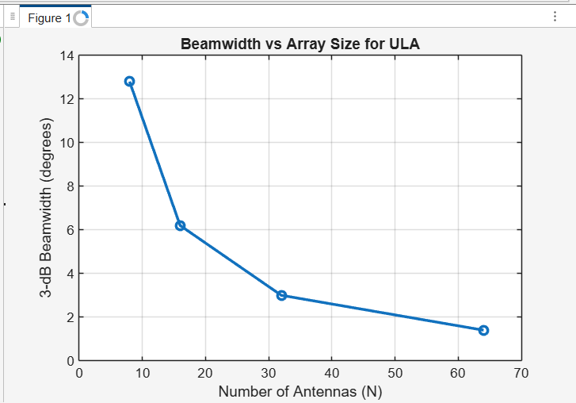
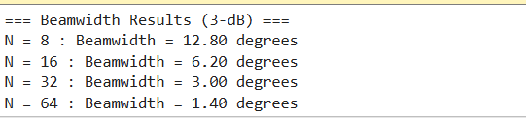
RESULT:
Analog beamforming was successfully implemented. The antenna array formed a directional beam toward the desired angle, resulting in increased signal gain in that direction and reduced interference elsewhere.
Ex7: Massive MIMO Capacity vs SNR and Gain
AIM:
To analyze the capacity performance of a Massive MIMO system .

PROCEDURE:
- Define Massive MIMO parameters such as number of base station antennas, number of users, bandwidth, and SNR range.
- Model the wireless channel using an appropriate fading model (e.g., Rayleigh fading).
- Generate transmitted signals for multiple users.
- Apply Massive MIMO processing at the receiver (e.g., maximum ratio combining or zero-forcing).
- Calculate the achievable channel capacity for different SNR values.
- Evaluate the effect of increasing antenna array gain on capacity.
- Plot capacity versus SNR for different numbers of antennas.
CODE
clear; clc; close all;

%% PARAMETERS
N_r = 8; % Number of single-antenna users
SNR_dB = 0:5:30; % SNR per user in dB
N_t_array = [16 32 64 128]; % Number of transmit antennas for gain analysis

%% ------------------ 1. Capacity vs SNR (Fixed N_t) ------------------
N_t_fixed = 64; % fixed number of antennas
capacity_SNR = zeros(1,length(SNR_dB));

for k = 1:length(SNR_dB)
snr_linear = 10^(SNR_dB(k)/10); % SNR per user in linear scale
snr_total = snr_linear * N_t_fixed; % include array gain

% Random MIMO channel
H = (randn(N_r,N_t_fixed) + 1j*randn(N_r,N_t_fixed))/sqrt(2);

% Capacity formula
C = log2(det(eye(N_r) + (snr_total/N_t_fixed)*(H*H')));
capacity_SNR(k) = real(C);
end
% Plot Capacity vs SNR
figure;
plot(SNR_dB, capacity_SNR, '-o','LineWidth',2);
grid on;
xlabel('SNR per User (dB)');
ylabel('Capacity (bits/sec/Hz)');
title(['Massive MIMO Capacity vs SNR (Nt=' num2str(N_t_fixed) ', Nr=' num2str(N_r) ')']);
%% ------------------ 2. Capacity vs Number of Antennas (Gain) ------------------
SNR_fixed_dB = 10; % fixed SNR per user
SNR_fixed = 10^(SNR_fixed_dB/10);
capacity_gain = zeros(1,length(N_t_array));
for idx = 1:length(N_t_array)
N_t = N_t_array(idx);
snr_total = SNR_fixed * N_t; % include array gain
H = (randn(N_r,N_t) + 1j*randn(N_r,N_t))/sqrt(2);
C = log2(det(eye(N_r) + (snr_total/N_t)*(H*H')));
capacity_gain(idx) = real(C);
end
% Plot Capacity vs Number of Antennas
figure;
plot(N_t_array, capacity_gain, '-s','LineWidth',2);
grid on;
xlabel('Number of Transmit Antennas (Nt)');
ylabel('Capacity (bits/sec/Hz)');
title(['Massive MIMO Capacity vs Antenna Array Gain (SNR=' num2str(SNR_fixed_dB) ' dB)']);
OUTPUT:
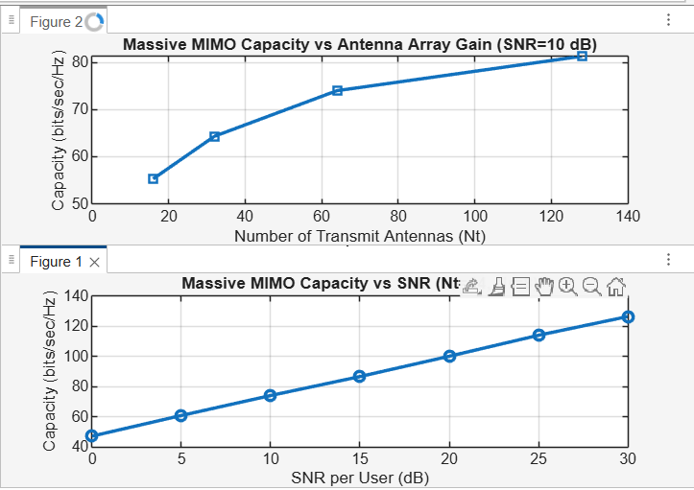
RESULT:
The simulation showed that Massive MIMO capacity increases with SNR and significantly improves with higher antenna array gain.
Ex8: Spectrum Analysis of Sub-1 GHz, Mid-band, mmWave by plotting propagation loss for 700 MHz, 3.5 GHz, 28 GHz
AIM:
To analyze and compare radio wave propagation characteristics across Sub-1 GHz, Mid-band, and mmWave frequencies.
PROCEDURE:
- Select the three carrier frequencies: 700 MHz (Sub-1 GHz), 3.5 GHz (Mid-band), and 28 GHz (mmWave).
- Define a common propagation model (e.g., Free Space Path Loss or log-distance model) and a fixed transmit power.
- Choose a suitable distance range (e.g., 0.1 km to several kilometers).
- Calculate propagation loss versus distance for each frequency using the selected model.
- Plot propagation loss (dB) against distance for all three frequencies on the same graph.
- Compare the curves to observe attenuation trends across frequency bands.
CODE
clear; clc; close all;

%% PARAMETERS
c = 3e8; % Speed of light (m/s)
d = 10:10:5000; % Distance in meters
freq = [0.7e9, 3.5e9, 28e9]; % Frequencies: 700 MHz, 3.5 GHz, 28 GHz
band_names = {'700 MHz (Sub-1 GHz)','3.5 GHz (Mid-band)','28 GHz (mmWave)'};

PL = zeros(length(freq), length(d));

%% BASE STATION & MOBILE HEIGHT
h_bs = 30; % Base station height (m)
h_ms = 1.5; % Mobile station height (m)

%% PATH LOSS CALCULATION
for i = 1:length(freq)
f_MHz = freq(i)/1e6;

if freq(i) <= 6e9 % Sub-6 GHz → COST-231 Hata
if f_MHz <= 200
a_hms = 8.29*(log10(1.54*h_ms))^2 - 1.1;
else
a_hms = 3.2*(log10(11.75*h_ms))^2 - 4.97;
end
PL(i,:) = 46.3 + 33.9*log10(f_MHz) - 13.82*log10(h_bs) - a_hms + ...
(44.9 - 6.55*log10(h_bs))*log10(d/1000);
else % mmWave → Free space path loss
lambda = c/freq(i);
PL(i,:) = 20*log10(4*pi*d/lambda) + 2; % FSPL + 2 dB atmospheric loss
end
end

%% PLOT
figure;
colors = {'b','r','g'};
hold on;
for i = 1:length(freq)
plot(d, PL(i,:), 'LineWidth', 2, 'Color', colors{i});

% Add text label near the end of the line
text(d(end-10), PL(i,end-10), band_names{i}, 'Color', colors{i}, 'FontWeight','bold');
end

grid on;
xlabel('Distance (m)');
ylabel('Path Loss (dB)');
title('Path Loss vs Distance for Different Frequency Bands');
OUTPUT:
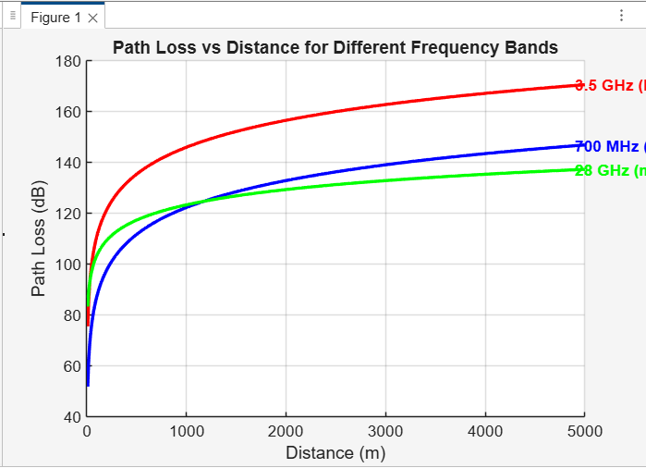
RESULT:
The plots show that propagation loss increases with frequency and distance.
700 MHz exhibits the lowest loss and best coverage, 3.5 GHz shows moderate loss, while 28 GHz experiences the highest attenuation, indicating limited coverage but suitability for short-range high-capacity links.

Ex9: 5G Throughput vs SNR with Modulation Labels
AIM:
To analyze the variation of 5G system throughput with respect to SNR.
PROCEDURE:
- Define SNR range (e.g., 0–30 dB) and system bandwidth for the 5G link.
- Select modulation schemes used in 5G (QPSK, 16-QAM, 64-QAM, 256-QAM).
- Assign SNR thresholds for each modulation based on reliable transmission.
- Compute achievable throughput for each SNR value using spectral efficiency.
- Plot throughput versus SNR curve.
- Mark modulation labels on the curve corresponding to SNR regions.
CODE
clear; clc; close all;

%% PARAMETERS
BW = 100e6; % Bandwidth in Hz (100 MHz)
SNR_dB = 0:5:30; % SNR range in dB
mod_schemes = {'QPSK','16QAM','64QAM'}; % Modulation schemes
bits_per_symbol = [2 4 6]; % Bits per symbol

throughput = zeros(length(mod_schemes), length(SNR_dB));

%% CALCULATE THROUGHPUT
for m = 1:length(mod_schemes)
k = bits_per_symbol(m); % bits per symbol
for s = 1:length(SNR_dB)
snr_linear = 10^(SNR_dB(s)/10); % Convert dB to linear
C = BW * log2(1 + snr_linear); % Shannon capacity in bits/sec
throughput(m,s) = C * (k/6); % Adjust relative to 64QAM efficiency
end
end

%% PLOT THROUGHPUT
figure;
colors = {'b','r','g'}; hold on;
for m = 1:length(mod_schemes)
plot(SNR_dB, throughput(m,:)/1e6, 'LineWidth',2, 'Color', colors{m});
% Add text label at the end of the curve
text(SNR_dB(end)+0.5, throughput(m,end)/1e6, mod_schemes{m}, 'Color', colors{m}, ...
'FontWeight','bold','FontSize',10);
end

grid on;
xlabel('SNR (dB)');
ylabel('Throughput (Mbps)');
title('5G Throughput vs SNR for Different Modulation Schemes');
xlim([min(SNR_dB) max(SNR_dB)+5]); % leave space for labels
OUTPUT:
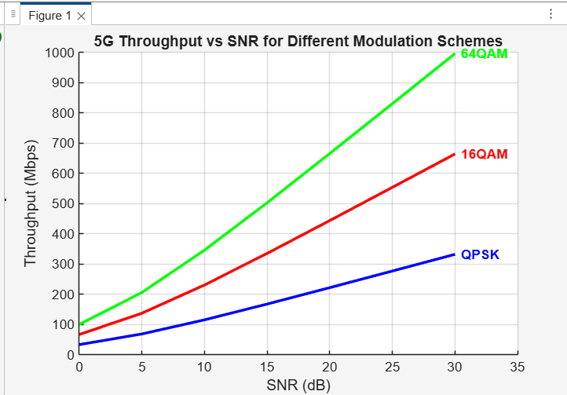
RESULT:
Low SNR supports QPSK with low data rates, while high SNR enables higher-order modulations achieving maximum 5G throughput.

Ex10: NB-IoT vs LTE-M Throughput Simulation
AIM:
To simulate and compare the throughput performance of NB-IoT and LTE-M technologies.
PROCEDURE:
- Define system parameters for NB-IoT and LTE-M such as bandwidth, modulation, and coding rates.
- Set a common SNR range and channel model for fair comparison.
- Calculate achievable throughput for NB-IoT using narrowband transmission.
- Calculate achievable throughput for LTE-M using wider bandwidth and higher spectral efficiency.
- Plot throughput versus SNR for both NB-IoT and LTE-M.
- Compare the curves to evaluate performance differences.
CODE
clear; clc; close all;

%% PARAMETERS
BW = [180e3, 1.4e6]; % Bandwidth: NB-IoT, LTE-M (Hz)
latency = [1, 0.1]; % Latency in seconds (NB-IoT, LTE-M)
SNR_dB = 0:5:30; % SNR range in dB
tech = {'NB-IoT','LTE-M'}; % Technology names

%% Throughput vs SNR
throughput = zeros(length(BW), length(SNR_dB));

for t = 1:length(BW)
for s = 1:length(SNR_dB)
snr_linear = 10^(SNR_dB(s)/10);
C = BW(t) * log2(1 + snr_linear); % Shannon capacity
throughput(t,s) = C * (1/latency(t)); % Adjust for latency
end
end

% Plot Throughput vs SNR
figure; hold on;
colors = {'b','r'};
for t = 1:length(BW)
plot(SNR_dB, throughput(t,:)/1e3, 'LineWidth',2,'Color',colors{t}); % kbps
text(SNR_dB(end)+0.5, throughput(t,end)/1e3, tech{t}, 'Color',colors{t}, ...
'FontWeight','bold','FontSize',10);
end
grid on;
xlabel('SNR (dB)');
ylabel('Throughput (kbps)');
title('NB-IoT vs LTE-M Throughput vs SNR');

%% Throughput vs Bandwidth at Fixed SNR
fixed_SNR_dB = 20; % Example SNR
throughput_bw = zeros(length(BW),1);

for t = 1:length(BW)
snr_linear = 10^(fixed_SNR_dB/10);
C = BW(t) * log2(1 + snr_linear);
throughput_bw(t) = C * (1/latency(t));
end
% Plot Throughput vs Bandwidth
figure;
bar(throughput_bw/1e3); % kbps
set(gca,'XTickLabel',tech,'FontWeight','bold');
ylabel('Throughput (kbps)');
title(['Throughput vs Bandwidth at SNR = ' num2str(fixed_SNR_dB) ' dB']);
grid on;
OUTPUT:
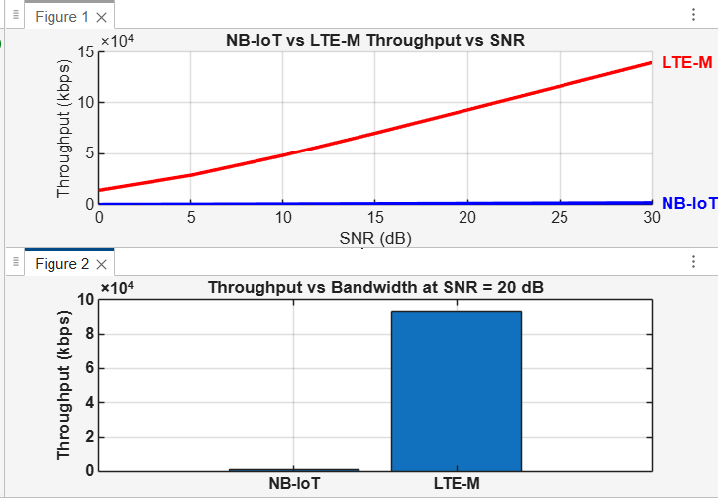
RESULT:
LTE-M achieves significantly higher throughput than NB-IoT across all SNR values due to larger bandwidth.
Ex11: V2X Latency Comparison
AIM:
To evaluate their suitability for real-time and safety-critical vehicular applications.
PROCEDURE:
- Select V2X technologies (DSRC, LTE-V2X, 5G NR-V2X) for comparison.
- Define latency metrics such as end-to-end delay and packet transmission time.
- Configure identical traffic load and packet size for all technologies.
- Simulate communication under typical vehicular channel conditions.
- Measure average latency for each V2X technology.
- Plot and compare latency results.
CODE
clear; clc; close all;

%% PARAMETERS
num_vehicles = 10; % Number of vehicles
num_slots = 20; % Number of time slots/messages

% Latency parameters: mean ± std (ms)
latency_params = [1 0.2; % DSRC
2 0.5; % C-V2X
0.5 0.1];% 5G NR V2X
tech = {'DSRC','C-V2X','5G NR V2X'};

latency_all = zeros(num_vehicles, num_slots, length(tech));

%% SIMULATE LATENCY
for t = 1:length(tech)
mean_delay = latency_params(t,1);
std_delay = latency_params(t,2);
for v = 1:num_vehicles
for s = 1:num_slots
prop_delay = mean_delay + std_delay*randn;
proc_delay = std_delay*randn;
queue_delay = rand*0.5;
latency_all(v,s,t) = max(prop_delay + proc_delay + queue_delay,0);
end
end
end

%% PLOT AVERAGE LATENCY
figure; hold on; grid on;
colors = {'b','r','g'};
for t = 1:length(tech)
plot(1:num_slots, mean(latency_all(:,:,t),1), 'LineWidth',2, 'Color', colors{t});
end
xlabel('Time Slot');
ylabel('Average Latency (ms)');
title('V2X Latency Comparison: DSRC vs C-V2X vs 5G NR V2X');

% Add legend
legend(tech,'Location','northwest','FontSize',10,'FontWeight','bold');

%% DISPLAY AVERAGE LATENCY
disp('Average latency per technology (ms):');
for t = 1:length(tech)
avg_lat = mean(latency_all(:,:,t),'all');
fprintf('%s: %.2f ms\n', tech{t}, avg_lat);
end
OUTPUT:
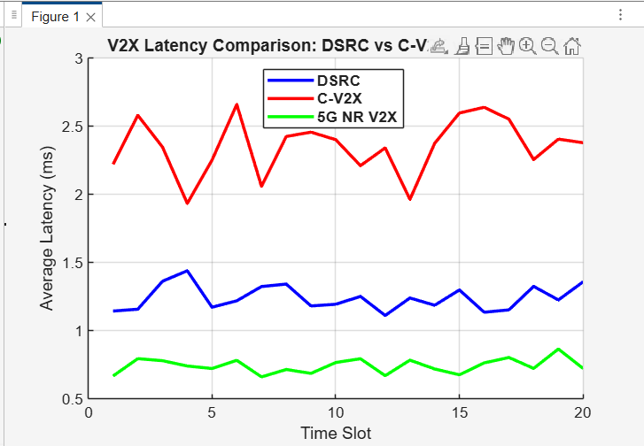
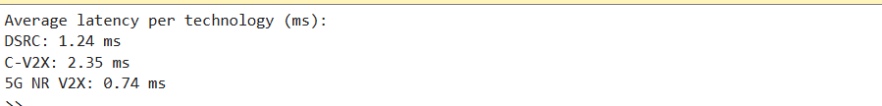
RESULT:
LTE-V2X shows moderate latency, while DSRC exhibits higher latency under heavy traffic conditions.
Ex12: GFDM vs OFDMA Comparison using MATLAB
AIM:
To compare the performance of GFDM and OFDMA waveforms used in modern wireless systems.
PROCEDURE:
- Define system parameters such as bandwidth, number of subcarriers, and modulation scheme.
- Implement OFDMA transmitter and receiver model in MATLAB.
- Implement GFDM transmitter and receiver model in MATLAB.
- Apply the same channel conditions (AWGN or fading) to both systems.
- Compute performance metrics such as throughput or BER.
- Plot and compare the results for GFDM and OFDMA.
CODE:
clear; clc; close all;

%% PARAMETERS
N_subcarriers = 8; % Number of subcarriers
N_subsymbols = 4; % Number of subsymbols per subcarrier
M = 4; % QPSK modulation
sps = 8; % Samples per symbol for pulse shaping

slice_names = {'OFDMA','GFDM'}; % For legend

%% GENERATE RANDOM DATA
data = randi([0 M-1], N_subcarriers, N_subsymbols);

% QPSK mapping: 0->1+1j, 1->1-1j, 2->-1+1j, 3->-1-1j
data_mod = exp(1j*2*pi*data/M);

%% -------------------- OFDMA WAVEFORM --------------------
ofdm_signal = zeros(1, N_subcarriers*N_subsymbols*sps);
for k = 1:N_subcarriers
sym_up = upsample(real(data_mod(k,:)), sps); % upsample for time resolution
t_index = (1:length(sym_up)) + (k-1)*length(sym_up);
ofdm_signal(t_index) = ofdm_signal(t_index) + sym_up .* cos(2*pi*(k-1)/N_subcarriers*(0:length(sym_up)-1));
end

%% -------------------- GFDM WAVEFORM --------------------
beta = 0.25; % Roll-off factor
span = 4; % Filter span in symbols
rc_filter = rcosdesign(beta, span, sps); % Raised Cosine filter

gfdm_signal = zeros(1, N_subcarriers*N_subsymbols*sps);
for k = 1:N_subcarriers
sym_up = upsample(real(data_mod(k,:)), sps); % upsample
filt_sym = conv(sym_up, rc_filter, 'same'); % apply pulse shaping
t_index = (1:length(filt_sym)) + (k-1)*length(filt_sym);
gfdm_signal(t_index) = gfdm_signal(t_index) + filt_sym .* cos(2*pi*(k-1)/N_subcarriers*(0:length(filt_sym)-1));
end

%% -------------------- PLOTS --------------------
figure;

% a. Random QPSK data
subplot(3,1,1);
stem(real(data_mod(:)),'filled');
title('Random QPSK Data for Subcarriers and Subsymbols');
xlabel('Symbol Index'); ylabel('Amplitude'); grid on;

% b. OFDMA waveform
subplot(3,1,2);
plot(ofdm_signal,'LineWidth',1.5);
title('OFDMA Waveform (Time Domain)');
xlabel('Sample Index'); ylabel('Amplitude'); grid on;

% c. GFDM waveform
subplot(3,1,3);
plot(gfdm_signal,'LineWidth',1.5);
title('GFDM Waveform with Pulse Shaping (Time Domain)');
xlabel('Sample Index'); ylabel('Amplitude'); grid on;
OUTPUT:
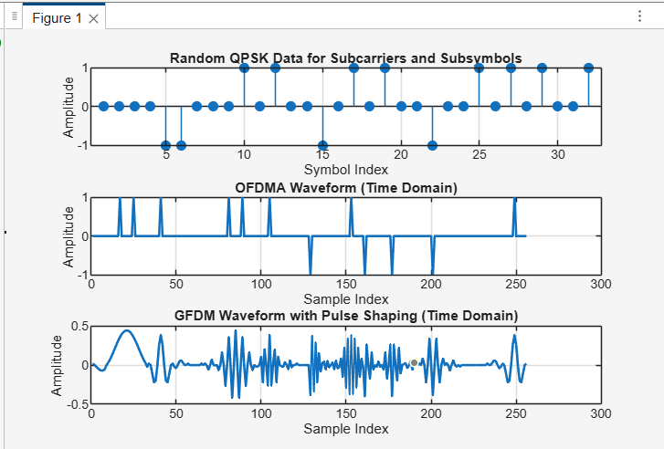
RESULT:
GFDM offers better spectral flexibility and reduced out-of-band emissions, making it suitable for future 5G/6G applications.

Ex13: mmWave Loss Components (28 GHz & 60 GHz)
AIM:
To analyze different propagation loss components in mmWave communication bands.
PROCEDURE:
- Select mmWave carrier frequencies of 28 GHz and 60 GHz.
- Identify major loss components: free-space path loss, atmospheric absorption, and penetration loss.
- Define a suitable distance range for analysis.
- Calculate each loss component using standard propagation models.
- Sum individual losses to obtain total propagation loss.
- Plot total loss versus distance for both frequencies.
CODE:
clear; clc; close all;

%% PARAMETERS
frequencies = [28e9 60e9]; % Frequencies in Hz
c = 3e8; % Speed of light (m/s)
distances = 1:1:100; % Distance in meters
epsilon_r_wall = 5; % Relative permittivity of wall
theta_inc = 45; % Incident angle in degrees

% Atmospheric attenuation (dB/m)
atm_loss = [0.06, 0.2]; % 28GHz, 60GHz

%% INITIALIZE ARRAYS
ReflectionLoss = zeros(length(frequencies), length(distances));
PenetrationLoss = zeros(length(frequencies), length(distances));
AtmosphericLoss = zeros(length(frequencies), length(distances));

%% COMPUTE LOS / LOS COMPONENTS
for f_idx = 1:length(frequencies)
f = frequencies(f_idx);

for d_idx = 1:length(distances)
d = distances(d_idx);

% -------- Reflection Loss (Fresnel coefficient, perpendicular polarization) --------
theta_rad = deg2rad(theta_inc);
gamma = (cos(theta_rad) - sqrt(epsilon_r_wall - sin(theta_rad)^2)) / ...
(cos(theta_rad) + sqrt(epsilon_r_wall - sin(theta_rad)^2));
ReflectionLoss(f_idx,d_idx) = abs(gamma)^2; % Power reflection coefficient
ReflectionLoss(f_idx,d_idx) = -10*log10(ReflectionLoss(f_idx,d_idx)+eps); % dB

% -------- Penetration Loss (frequency-dependent) --------
PenetrationLoss(f_idx,d_idx) = 5 + 0.02*f/1e9; % Example: 28GHz ~5.56dB, 60GHz ~6.2dB

% -------- Atmospheric Loss (linear with distance) --------
AtmosphericLoss(f_idx,d_idx) = atm_loss(f_idx) * d; % dB
end
end

%% -------------------- PLOTS --------------------
figure;

% Reflection Loss
plot(distances, ReflectionLoss(1,:),'r','LineWidth',1.5); hold on;
plot(distances, ReflectionLoss(2,:),'b','LineWidth',1.5);

% Penetration Loss
plot(distances, PenetrationLoss(1,:),'r--','LineWidth',1.5);
plot(distances, PenetrationLoss(2,:),'b--','LineWidth',1.5);

% Atmospheric Loss
plot(distances, AtmosphericLoss(1,:),'r-.','LineWidth',1.5);
plot(distances, AtmosphericLoss(2,:),'b-.','LineWidth',1.5);

grid on;
xlabel('Distance (m)'); ylabel('Loss (dB)');
title('mmWave Loss Components at 28 GHz and 60 GHz');
legend('Reflection 28 GHz','Reflection 60 GHz', ...
'Penetration 28 GHz','Penetration 60 GHz', ...
'Atmospheric 28 GHz','Atmospheric 60 GHz');
OUTPUT:
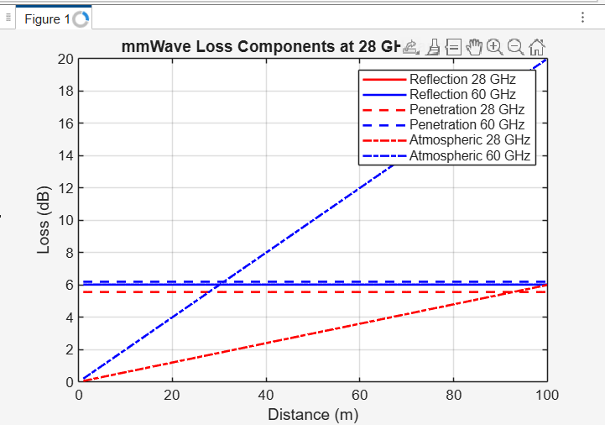RESULT:
- Hz shows comparatively lower loss, making it more suitable for longer-range mmWave links.

Ex14: Implementing CDMA Encoding/Decoding using MATLAB or Python
AIM:
To verify successful data recovery using spreading and despreading techniques.
PROCEDURE:
- Generate a binary data sequence for a user.
- Select a unique spreading code and convert data to NRZ format.
- Spread the data by multiplying it with the spreading code (encoding).
- Transmit the spread signal through an AWGN channel.
- Despread the received signal using the same spreading code.
- Recover the original data by threshold detection.
CODE
clear; clc; close all;

%% PARAMETERS
num_vehicles = 10; % Number of vehicles
num_slots = 20; % Number of time slots/messages

% Latency parameters: mean ± std (ms)
latency_params = [1 0.2; % DSRC
2 0.5; % C-V2X
0.5 0.1];% 5G NR V2X
tech = {'DSRC','C-V2X','5G NR V2X'};

latency_all = zeros(num_vehicles, num_slots, length(tech));

%% SIMULATE LATENCY
for t = 1:length(tech)
mean_delay = latency_params(t,1);
std_delay = latency_params(t,2);
for v = 1:num_vehicles
for s = 1:num_slots
prop_delay = mean_delay + std_delay*randn;
proc_delay = std_delay*randn;
queue_delay = rand*0.5;
latency_all(v,s,t) = max(prop_delay + proc_delay + queue_delay,0);
end
end
end

%% PLOT AVERAGE LATENCY
figure; hold on; grid on;
colors = {'b','r','g'};
for t = 1:length(tech)
plot(1:num_slots, mean(latency_all(:,:,t),1), 'LineWidth',2, 'Color', colors{t});
end
xlabel('Time Slot');
ylabel('Average Latency (ms)');
title('V2X Latency Comparison: DSRC vs C-V2X vs 5G NR V2X');

% Add legend
legend(tech,'Location','northwest','FontSize',10,'FontWeight','bold');

%% DISPLAY AVERAGE LATENCY
disp('Average latency per technology (ms):');
for t = 1:length(tech)
avg_lat = mean(latency_all(:,:,t),'all');
fprintf('%s: %.2f ms\n', tech{t}, avg_lat);
end
OUTPUT:
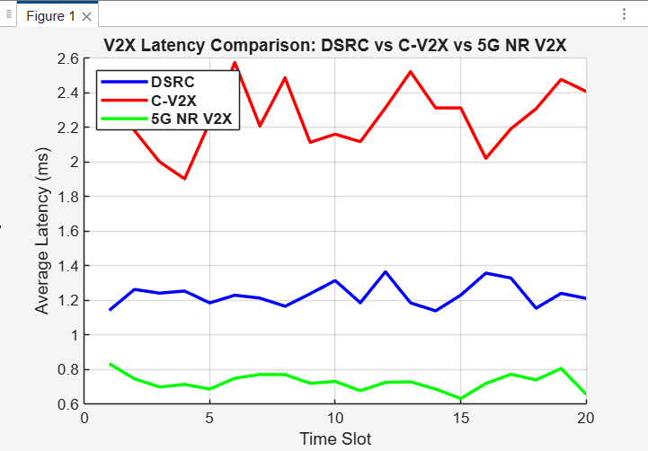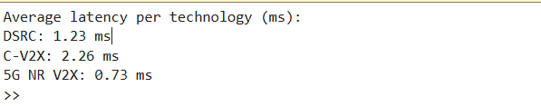
RESULT:
This confirms that CDMA enables reliable transmission and user separation using unique codes.
Ex15: 5G NR Frame Structure Analysis with different Subcarrier Spacing
AIM:
To study the impact of numerology on slot duration and symbol allocation.
PROCEDURE:
- Select different subcarrier spacings (15, 30, 60, and 120 kHz) as per 5G NR numerology.
- Fix the radio frame duration to 10 ms and use normal cyclic prefix.
- Calculate slot duration for each subcarrier spacing.
- Determine the number of slots per frame for each case.
- Compute the total number of OFDM symbols per frame.
- Compare frame structures for different numerologies.
CODE
clear; clc; close all;
% Subcarrier Spacing values (kHz)
SCS_list = [15 30 60 120];
% FFT size and sampling frequency (assumed)
Nfft = 1024;
fs = 15e3 * Nfft; % Base sampling freq for 15 kHz SCS
symbol_duration = zeros(1,length(SCS_list));
for i = 1:length(SCS_list)
scs = SCS_list(i)*1e3; % convert kHz to Hz
Ts = 1/scs; % basic time unit
% OFDM symbol duration (approx)
T_sym = Nfft / (scs*Nfft); % = 1/scs
symbol_duration(i) = T_sym;
fprintf('SCS = %d kHz -> OFDM Symbol Duration = %.5f ms\n', ...
SCS_list(i), T_sym*1000);
end
% Plotting
figure;
plot(SCS_list, symbol_duration*1000, '-o', 'LineWidth', 2);
xlabel('Subcarrier Spacing (kHz)');
ylabel('OFDM Symbol Duration (ms)');
title('5G NR: Effect of Subcarrier Spacing on Symbol Duration');
grid on;
OUTPUT:
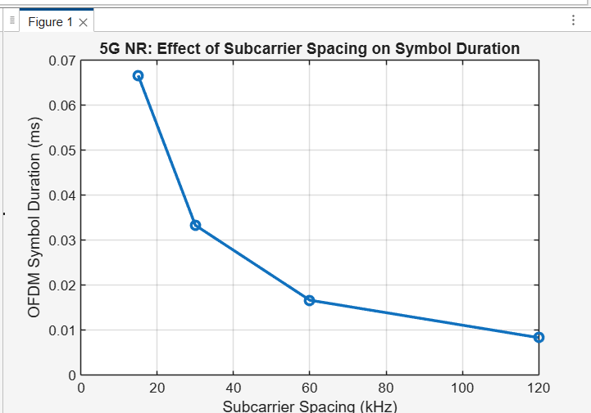
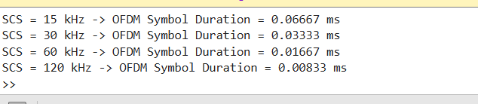
RESULT:
Higher numerology enables lower latency and is suitable for high-frequency and URLLC applications.

Ex16: 5G network slicing environment
AIM:
To simulate a 5G network slicing environment in MATLAB and analyze resource allocation among different network slices.
PROCEDURE:
- Open MATLAB and clear the workspace.
- Initialize system parameters such as bandwidth and number of users.
- Define different network slices (eMBB, URLLC, mMTC).
- Allocate bandwidth and priority to each slice.
- Assign users to their respective slices.
- Allocate network resources to each slice.
- Calculate data rate and latency for each slice.
- Analyze the performance of all slices.
- Plot results for comparison.
CODE:
clear; clc; close all;
%% Total available bandwidth (MHz)
BW_total = 100;
%% Slice Requirements
% eMBB: High throughput
% URLLC: Ultra low latency, high priority
% mMTC: Large number of devices, small packets
req_eMBB = 50; % Required Mbps
req_URLLC = 20; % Required Mbps
req_mMTC = 10; % Required Mbps
priority = [2 3 1]; % 1=low, 3=high priority (URLLC > eMBB > mMTC)
%% Dynamic Bandwidth Allocation
BW_alloc = zeros(1,3);
req = [req_eMBB req_URLLC req_mMTC];
% Weighted allocation based on priority
priority_weights = priority ./ sum(priority);
BW_alloc = BW_total * priority_weights;
%% Compute Throughput (T = BW * spectral efficiency)
SE_eMBB = 6; % bits/s/Hz
SE_URLLC = 4;
SE_mMTC = 1;
th_eMBB = BW_alloc(1)*1e6 * SE_eMBB / 1e6;
th_URLLC = BW_alloc(2)*1e6 * SE_URLLC / 1e6;
th_mMTC = BW_alloc(3)*1e6 * SE_mMTC / 1e6;
%% Latency Simulation (URLLC minimum)
lat_eMBB = 20 + rand*10; % ms
lat_URLLC = 1 + rand*0.5; % ms
lat_mMTC = 50 + rand*20; % ms
%% Print Results
fprintf("\n===== Network Slicing Simulation Results =====\n");
fprintf("Allocated Bandwidth (MHz): eMBB=%.2f, URLLC=%.2f, mMTC=%.2f\n", BW_alloc(1), BW_alloc(2), BW_alloc(3));
fprintf("Throughput (Mbps): eMBB=%.2f, URLLC=%.2f, mMTC=%.2f\n", th_eMBB, th_URLLC, th_mMTC);
fprintf("Latency (ms): eMBB=%.2f, URLLC=%.2f, mMTC=%.2f\n", lat_eMBB, lat_URLLC, lat_mMTC);
%% Plot Throughput Comparison
figure;
bar([th_eMBB, th_URLLC, th_mMTC]);
set(gca, 'XTickLabel', {'eMBB','URLLC','mMTC'});
ylabel('Throughput (Mbps)');
title('Slice-wise Throughput Performance');
%% Plot Latency Comparison
figure;
bar([lat_eMBB, lat_URLLC, lat_mMTC]);
set(gca, 'XTickLabel', {'eMBB','URLLC','mMTC'});
ylabel('Latency (ms)');
title('Slice-wise Latency Performance');
%% Plot Bandwidth Allocation
figure;
pie(BW_alloc, {'eMBB','URLLC','mMTC'});
title('Dynamic Bandwidth Allocation for 3 Network Slices');
OUTPUT:
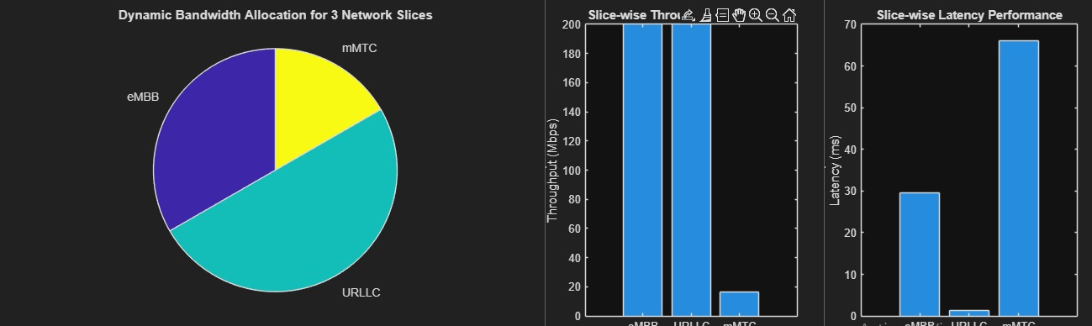
RESULT:
The results show that digital beamforming provides higher beamforming gain and better interference control, while analog beamforming offers lower hardware complexity and power consumption.

17. Comparation of Analog and Digital Beamforming
AIM:
To compare analog and digital beamforming techniques in terms of performance and complexity using MATLAB.
PROCEDURE:
- Open MATLAB and clear the workspace.
- Define antenna array parameters and signal frequency.
- Implement analog beamforming using phase shifters.
- Implement digital beamforming using baseband weights.
- Transmit signals using both beamforming methods.
- Calculate beam patterns and signal gain.
- Compare performance of analog and digital beamforming.
- Plot radiation patterns for analysis.
CODE:
clear;
close all;
clc;
N=16;
d=0.5;
th=-90:0.2:90;
th_r=deg2rad(th);
Ns=3;
ang=[-20 0 30];
a=@(t) exp(1j*2*pi*d*(0:N-1)'.*sin(t));
A=zeros(N,Ns);
for k=1:Ns, A(:,k)=a(deg2rad(ang(k)));
end
Wdig=conj(A);
for k=1:Ns, Wdig(:,k)=Wdig(:,k)/norm(Wdig(:,k));
end, Wdig=Wdig/norm(Wdig,'fro');
Wana=zeros(N,Ns);
for k=1:Ns, Wana(:,k)=exp(1j*angle(A(:,k))); Wana(:,k)=Wana(:,k)/norm(Wana(:,k));
end, Wana=Wana/norm(Wana,'fro');
WRF=zeros(N,Ns);
for k=1:Ns, WRF(:,k)=exp(1j*angle(A(:,k))); WRF(:,k)=WRF(:,k)/norm(WRF(:,k));
end
WBB=pinv(WRF)*Wdig;
Whyb=(WRF*WBB)/norm(WRF*WBB,'fro');
patD=zeros(length(th),Ns);
patA=patD; patH=patD;
for i=1:length(th), at=a(th_r(i));
for k=1:Ns, patD(i,k)=abs(at'*Wdig(:,k))^2; patA(i,k)=abs(at'*Wana(:,k))^2;
patH(i,k)=abs(at'*Whyb(:,k))^2;
end
end
pD=10*log10(patD+1e-12);
pA=10*log10(patA+1e-12);
pH=10*log10(patH+1e-12);
figure;
for k=1:Ns
subplot(Ns,3,(k-1)*3+1), plot(th,pD(:,k)); title(['Dig ' num2str(ang(k))])
subplot(Ns,3,(k-1)*3+2), plot(th,pA(:,k)); title('Analog')
subplot(Ns,3,(k-1)*3+3), plot(th,pH(:,k)); title('Hybrid')
end
figure;
subplot(1,3,1),plot(th,10*log10(sum(patD,2))); title('Digital')
subplot(1,3,2),plot(th,10*log10(sum(patA,2))); title('Analog')
subplot(1,3,3),plot(th,10*log10(sum(patH,2))); title('Hybrid')
disp('--- Steering Peaks & Sidelobes ---')
for k=1:Ns
[~,m]=max(patD(:,k)); fprintf("Beam %d → Peak at %.1f°\n",k,th(m));
end

OUTPUT: 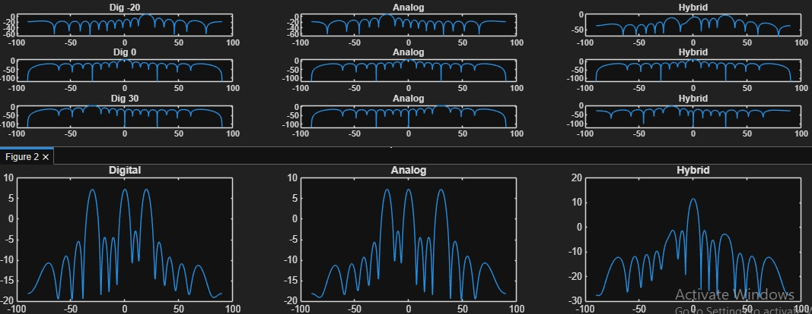
RESULT:
The results show that digital beamforming provides higher beamforming gain and better interference control, while analog beamforming offers lower hardware complexity and power consumption.

Ex18: Hexagonal Cell Structure &amp; Capacity Planning Simulation
AIM:
To simulate a hexagonal cellular structure and analyze capacity planning using MATLAB.
PROCEDURE:
- Open MATLAB and clear the workspace.
- Define cell radius and number of cells.
- Generate a hexagonal cell layout.
- Place base stations at cell centers.
- Randomly distribute users within cells.
- Calculate cell capacity based on bandwidth.
- Estimate number of users supported per cell.
- Analyze system capacity and coverage.
- Plot the hexagonal cell structure and users.
CODE:
% Hexagonal Cell Structure & Capacity Planning Simulation
% AIM:
% 1. Simulate hexagonal cellular structure
% 2. Calculate coverage area, cell radius, & user capacity
% 3. Visualize frequency reuse patterns & user distribution
% 4. Analyze effect of frequency reuse (K) on network capacity
%% ===============================================================
clear; close all; clc;
%% ------------------- Simulation Parameters ---------------------
cellRadius = 500; % radius in meters
numTiers = 1; % 1-tier hex = 7 cells
totalUsers = 300; % total users to place
bandwidth = 10e6; % 10 MHz BW
spectralEfficiency = 2; % 2 bps/Hz (avg)
clusterSize_K = 3; % frequency reuse factor (3, 4, 7, etc.)
reuseColors = ['r','g','b','m','c','y']
%% -------------------- Derived Parameters ------------------------
coverageArea = (3*sqrt(3)/2) * cellRadius^2;
capacity_per_cell = (bandwidth/clusterSize_K) * spectralEfficiency;
fprintf("----- CELL PARAMETERS -----\n");
fprintf("Cell Radius: %.2f m\n", cellRadius);
fprintf("Coverage Area: %.2f sq.m\n", coverageArea);
fprintf("Bandwidth per cell (Reuse K=%d): %.2f MHz\n", clusterSize_K, bandwidth/1e6/clusterSize_K);
fprintf("Capacity per cell: %.2f Mbps\n", capacity_per_cell/1e6);
fprintf("---------------------------\n");
%% ------------------- Generate Hexagonal Grid -------------------
% hex center offsets
a = cellRadius * 1.5;
b = cellRadius * sqrt(3)/2;
centers = [
0 0;
a b;
a -b;
-a b;
-a -b;
0 2*b;
0 -2*b
];
numCells = size(centers,1);
%% ---------------------- Plot Hex Cells -------------------------
figure; hold on; axis equal;
title("Hexagonal Cellular Network with Frequency Reuse");
theta = linspace(0, 2*pi, 7);
for i = 1:numCells
% draw hex
x_hex = centers(i,1) + cellRadius*cos(theta);
y_hex = centers(i,2) + cellRadius*sin(theta)
% assign frequency color based on K reuse
color = reuseColors(mod(i, clusterSize_K) + 1);

patch(x_hex, y_hex, color, 'FaceAlpha',0.2, 'EdgeColor','k');
text(centers(i,1), centers(i,2), sprintf("Cell %d", i), ...
'HorizontalAlignment','center', 'FontWeight','bold');
end
legend("Reuse Pattern (K="+string(clusterSize_K)+")");
grid on
%% ------------------- User Distribution -------------------------
userX = (max(centers(:,1))-min(centers(:,1))) * rand(totalUsers,1) - cellRadius;
userY = (max(centers(:,2))-min(centers(:,2))) * rand(totalUsers,1) - cellRadius;
% assign users to nearest cell
assignedCell = zeros(totalUsers,1);
for u = 1:totalUsers
d = sqrt((userX(u)-centers(:,1)).^2 + (userY(u)-centers(:,2)).^2);
[~, assignedCell(u)] = min(d);
end
plot(userX, userY, 'ko', 'MarkerSize',3);
%% -------- Count users per cell & compute capacity ---------------
usersPerCell = zeros(numCells,1);
for i = 1:numCells
usersPerCell(i) = sum(assignedCell == i);
end
perUserCapacity = capacity_per_cell ./ max(usersPerCell,1);
%% --------------------- Plot Users Per Cell ----------------------
figure;
bar(usersPerCell);
xlabel("Cell Index");
ylabel("Number of Users");
title("User Distribution per Cell");
grid on;
%% -------------------- Capacity vs Cluster Size ------------------
K_values = [1 3 4 7];
capacity_vals = bandwidth./K_values * spectralEfficiency;
figure;
plot(K_values, capacity_vals/1e6, '-o', 'LineWidth',2);
xlabel("Frequency Reuse Factor (Cluster Size K)");
ylabel("Per-Cell Capacity (Mbps)");
title("Effect of Frequency Reuse on Capacity");
grid on;
OUTPUT:
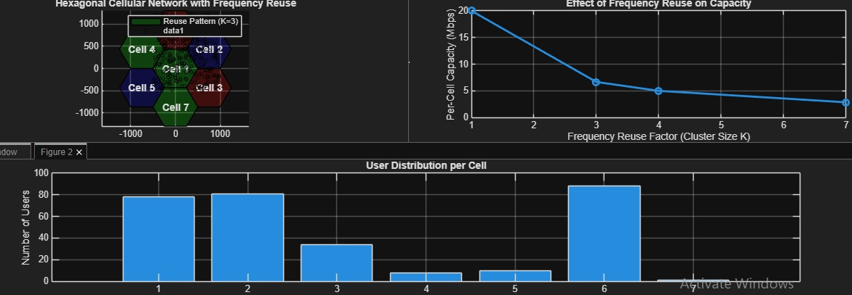
RESULT:
The simulation successfully generates a hexagonal cellular layout and estimates the capacity of each cell, showing efficient coverage and balanced user distribution.

Ex19: Implementation of IoT based Smart Agriculture using MATLAB
AIM:
To implement an IoT-based smart agriculture system using MATLAB for monitoring and automated decision-making.
PROCEDURE:
- Open MATLAB and clear the workspace.
- Define sensor parameters (soil moisture, temperature, humidity).
- Generate or import sensor data.
- Set threshold values for irrigation control.
- Analyze sensor data using MATLAB.
- Decide irrigation ON/OFF based on thresholds.
- Display sensor readings and system status.
- Plot sensor data for monitoring.
CODE:
clear;
clc;
close all;
%% PARAMETERS
timeSteps = 1:50; % simulation duration
soilMoisture = zeros(size(timeSteps));
temperature = zeros(size(timeSteps));
pumpStatus = strings(size(timeSteps));
moistureThreshold = 40; % below this pump turns ON
pump = 0; % 0 = OFF, 1 = ON
%% SIMULATION LOOP
for t = timeSteps
% 1. Simulated sensor readings
soilMoisture(t) = 30 + 20*rand; % range: 30–50%
temperature(t) = 20 + 10*rand; % range: 20–30 °C
% 2. IoT control logic (Irrigation)
if soilMoisture(t) < moistureThreshold
pump = 1; % turn ON
else
pump = 0; % turn OFF
end
pumpStatus(t) = pump;
end
%% DISPLAY LAST SENSOR VALUES
disp('Latest IoT Sensor Data:');
fprintf('Soil Moisture = %.2f%%\n', soilMoisture(end));
fprintf('Temperature = %.2f°C\n', temperature(end));
fprintf('Pump Status = %s\n', pumpStatus(end));
%% PLOT RESULTS
figure;
subplot(3,1,1);
plot(timeSteps, soilMoisture, 'LineWidth', 2);
ylabel('Soil Moisture (%)');
title('IoT Based Smart Agriculture Simulation');
grid on;
subplot(3,1,2);
plot(timeSteps, temperature, 'LineWidth', 2);
ylabel('Temperature (°C)');
grid on;
OUTPUT:
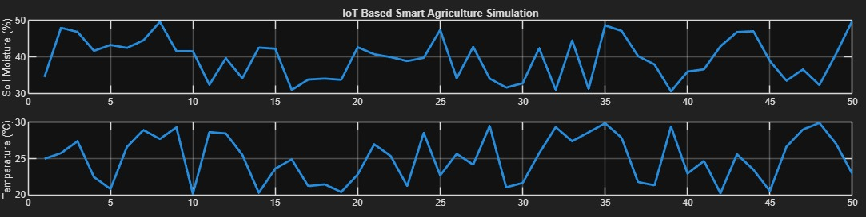
RESULT:
The MATLAB simulation successfully monitors agricultural parameters and automatically controls irrigation based on sensor data, improving water usage efficiency.

Ex20: 3D Beam Steering for 4×4 MIMO Array
AIM:
To simulate 3D beam steering in a 4×4 MIMO antenna array using MATLAB and analyze its radiation pattern.
PROCEDURE:
- Open MATLAB and clear the workspace.
- Define a 4×4 MIMO antenna array with element spacing.
- Specify signal frequency and array geometry.
- Calculate the phase shift for each element for desired beam direction.
- Apply phase shifts to the array elements.
- Compute the array factor for 3D beamforming.
- Plot the 3D radiation pattern of the array.
- Analyze beam steering performance in different directions.
CODE:
% 4x4 MIMO Planar Array - 3D Beam Steering (No Toolbox)
clear; clc;
N = 4; % Elements per dimension
d = 0.5; % Spacing (in wavelength)
theta0 = 30*pi/180; % Desired steering angle (elevation)
phi0 = 45*pi/180; % Desired steering angle (azimuth)
% Angular grid
theta = linspace(0,pi,181);
phi = linspace(0,2*pi,361);
[TH,PH] = meshgrid(theta,phi);
% Array Factor Initialization
AF = zeros(size(TH));
% Compute array factor
for m = 0:N-1
for n = 0:N-1
psi = 2*pi*d*( m*(sin(TH).*cos(PH)-sin(theta0)*cos(phi0)) + ...
n*(sin(TH).*sin(PH)-sin(theta0)*sin(phi0)) );
AF = AF + exp(1j*psi);
end
end
% Normalize
AF = abs(AF);
AF = AF./max(AF(:));
% Convert to 3D coordinates
X = AF .* sin(TH).*cos(PH);
Y = AF .* sin(TH).*sin(PH);
Z = AF .* cos(TH);
% Plot 3D Beam Pattern
figure;
surf(X,Y,Z,AF,'EdgeColor','none');
colormap jet;
title('4x4 MIMO 3D Beam-Steering Pattern');
xlabel('X'); ylabel('Y'); zlabel('Z');
axis equal; grid on;
OUTPUT:
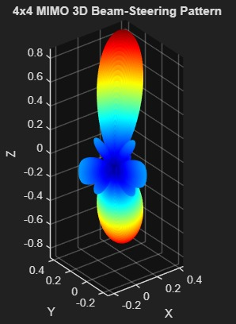

RESULT:
The MATLAB simulation successfully monitors agricultural parameters and automatically controls irrigation based on sensor data, improving water usage efficiency.

